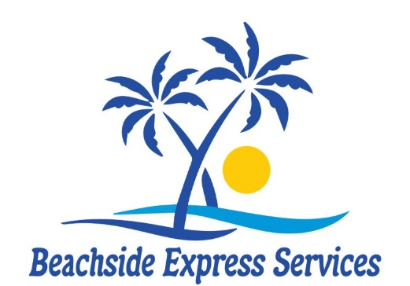
Cell 910-612-3886
beachsideexpressservices@gmail.com

Our all-white premium linens and towels are commercially laundered and sanitized!

Linen Rentals
Single/Twin Set: Fitted sheet, flat sheet, pillowcase, 1 bath towel, 1 hand towel, 1 washcloth = $22
Double/Full Set: Fitted sheet, flat sheet, 2 pillowcases, 2 bath towels, 2 hand towels, 2 washcloths = $28
Queen Set: Fitted sheet, flat sheet, 2 pillowcases, 2 bath towels, 2 hand towels, 2 washcloths = $30
King Set: Fitted sheet, flat sheet, 2 pillowcases, 2 bath towels, 2 hand towels, 2 washcloths = $32
Extra Towel Set: 1 bath towel, 1 hand towel, 1 washcloth = $8
2 Kitchen towels & 1 Sponge = $6
Bathmat = $3 each
Extra bath towel = $5
XL Beach towel = $8

Guest Amenity Starter Pack = $20
1 roll of paper towels & 2 rolls of toilet paper
1 shampoo & 1 conditioner & 1 lotion & 1 body wash (All travel size)
1 small liquid dish soap & 1 dishwasher tablet
2 K-cups (coffee)

